6.TM Simulation for Palindrome W= ababa c

DESIGN:

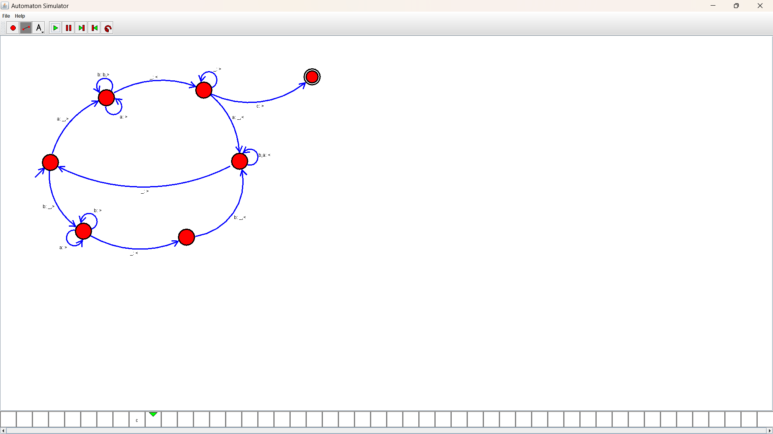

OUTPUT:

